**Effective Discipleship Ministry**

**Why we do it this way?  
Why we do it in this order?**

**What is the goal?   
When do we finish discipling?**

**Ephesians 4:13 *…until we all reach unity in the faith and in the knowledge of the Son of God and become mature, attaining to the whole measure of the fullness of Christ.***

Discipleship is not a __________ nor an event; it is a way of life. It is not for a limited amount of time, but for a __________. Discipleship is not just one of the things that the church does; it is what the church does.

For many people, as soon as the program ends their __________ ends.

**Goal of discipleship** – Eph. 4:13 for all together become mature in Christ

**Discipleship should be segmented and sequential.**

* Christ expected that his disciples matured as their relationship progressed.

**Two types of sequence**

* __________
* Upward __________

**Linear Sequence**

The four stages that Christ used

* “come and see”,
* “come and follow me”,
* “come and stay with me”
* “__________ in me”

**Upward Spiral Sequence**

The progression of 2 Peter 1.5–8

5 For this very reason, make every effort to add

* to your faith 🡪 goodness;
* and to goodness, 🡪 knowledge;
* 6 and to knowledge, 🡪 self-control;
* and to self-control, 🡪 perseverance;
* and to perseverance, 🡪 godliness;
* 7 and to godliness, 🡪 brotherly kindness;
* and to brotherly kindness, 🡪 love.

8 For if you possess these qualities in increasing measure, they will keep you from being ineffective and unproductive in your knowledge of our Lord Jesus Christ.

Jesus had to repeat teaching on serving, humility, forgiveness, commitment…

**THE SEQUENCE AND SEGMENTS**

**1. Discipleship starts with** ______________**.**

A. Evangelistic study “The 5 Spiritual Principles”.

* + - * Learns to be responsible for their relationship with God.
      * Learns the discipline of studying and doing homework each week.
      * Learns that baptism is only the beginning and not the end.

B. “The First 40 Days” <http://www.palmdalecoc.org/your-first-40-days/>

* + - * Learns how to have a devotional time and make application to their life.
      * Learns to share their salvation that he has just received.

**2. The Discipleship Ministry**

**Discipleship Introductory Study**

**To ______, to ______, and to _________, –** An introductory course that explains the foundation of the discipleship ministry and the need of being disciple to the new Christian. One comes to understand the sequence of the discipleship ministry and the three areas in which the new Christian will work which are Christian Character, Ministry Ability and Bible Knowledge.

**The goals of this study is to accomplish in the life of the new disciple that he may…**

* … understand what is a disciple.
* … learn the discipline of studying and participating in a group.
* … learn that discipleship has three parts.
* … recognize that discipleship is for life.

**Level 1 – Learning to be a Disciple (2 years) –** The disciple is challenged with the basic discipleship principles and being a faithful member of the church.

**First level slogan:   
“Nothing has been _________until it has been learned.   
And nothing has been learned until it has been _________.”**

|  |  |  |  |
| --- | --- | --- | --- |
| Trimester | Bible Knowledge | Ministry Ability | Spiritual Character |
| 1 | Spiritual Disciplines | Daily Devotion Time 1 | Sharing Your Salvation |
| 2 | Life of Christ 1 | Attending My Church | Being Trustworthy |
| 3 | Life of Christ 2 | Spiritual Gifts | Repentance for My Sin |
| 4 | Bible Doctrine | Christian Giving | Prayerful Spirit |
| 5 | O.T. Events | Daily Devotion Time 2 | Serving with Excellence |
| 6 | N. T. Survey | Testify | Commitment to my Church |

**NOTES AND OBSERVATIONS**



**Level 2 –** Learning to serve (15 months) The disciple is prepared to participate in the ministries of service within the church while developing the essential character as a servant of God.

**Second level slogan:  
*“He that serves, is useful  
he who does not serve, is* _________*.”***

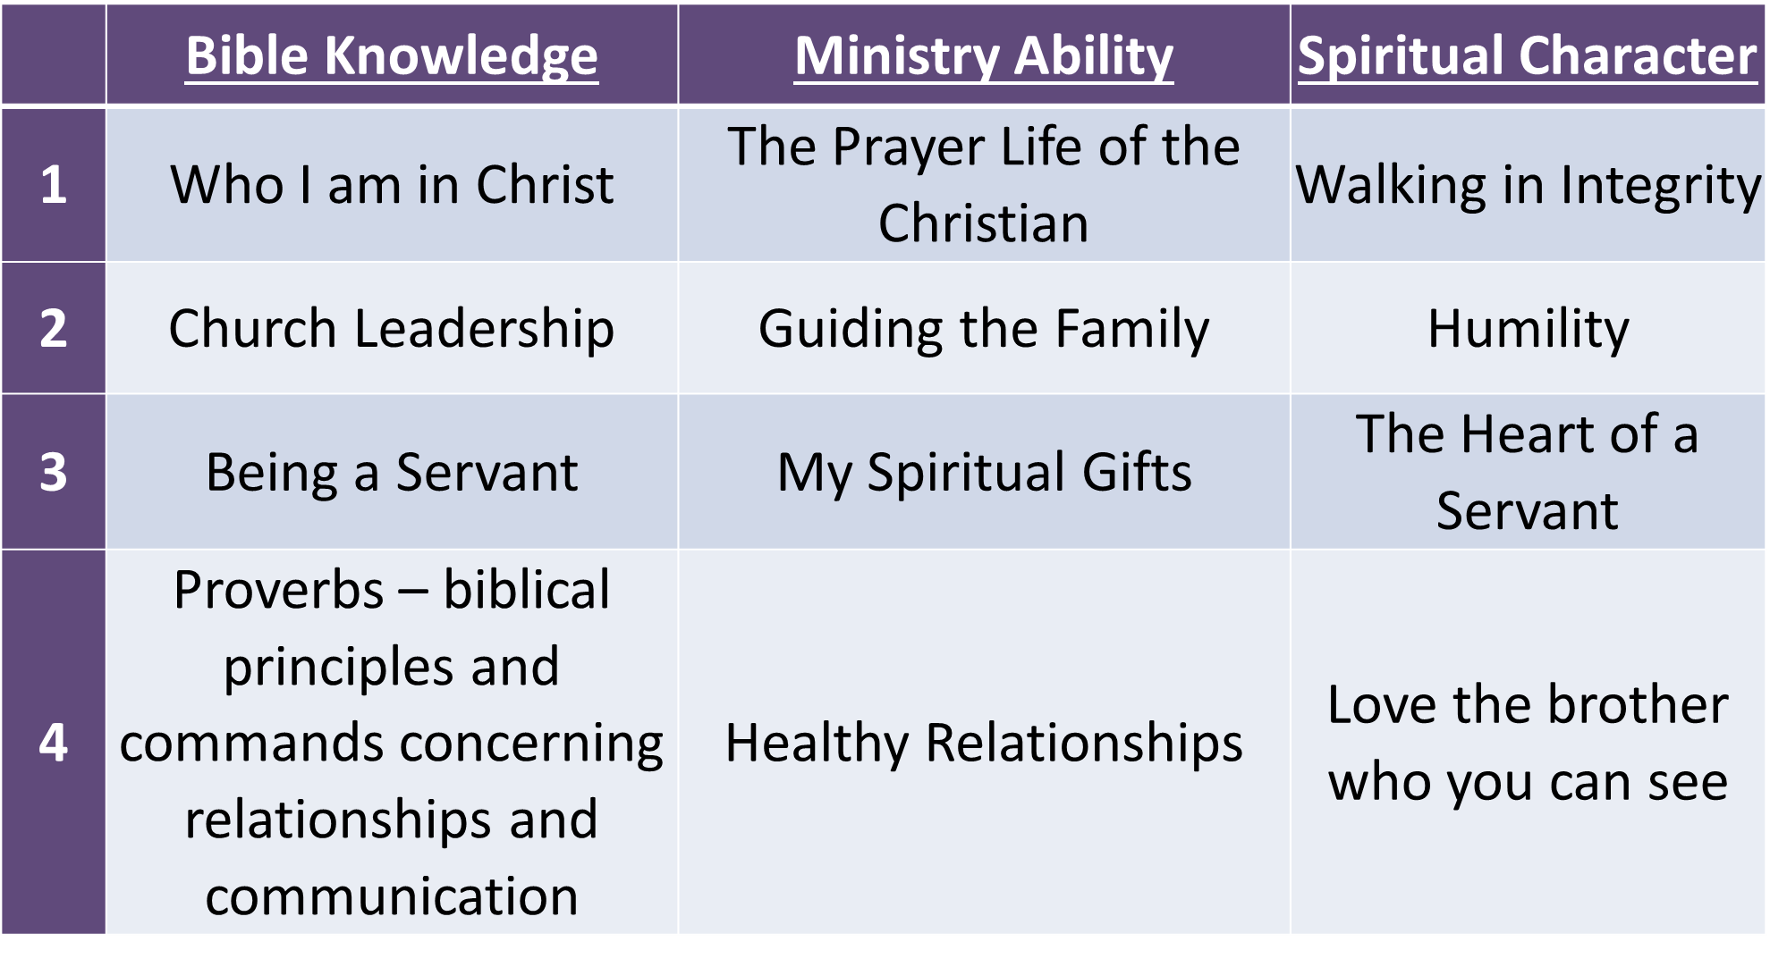

**NOTES AND OBSERVATIONS**



**Level 3 –** Learning to teach (3 years) The Fruit of the Spirit is emphasized as the necessary characteristics for one who teaches the Word of God, and is complemented by learning how to correctly using the biblical text within its context and the abilities to teach that results in the disciple being prepared by the Spirit to teach in the various teaching ministries of the local church.

**Third level slogan:**

***“... And the things you have heard me say in the presence of many witnesses entrust to reliable men who will also be qualified to teach others.” 2 Timothy 2:2***

**The Two Main Books Used in Third Level**

***How to Study the Bible***by Kay Arthur – Observation, interpretation and application – Inductive Bible Study

***Teaching to Change Lives***by Howard Hendricks – The seven laws of the teacher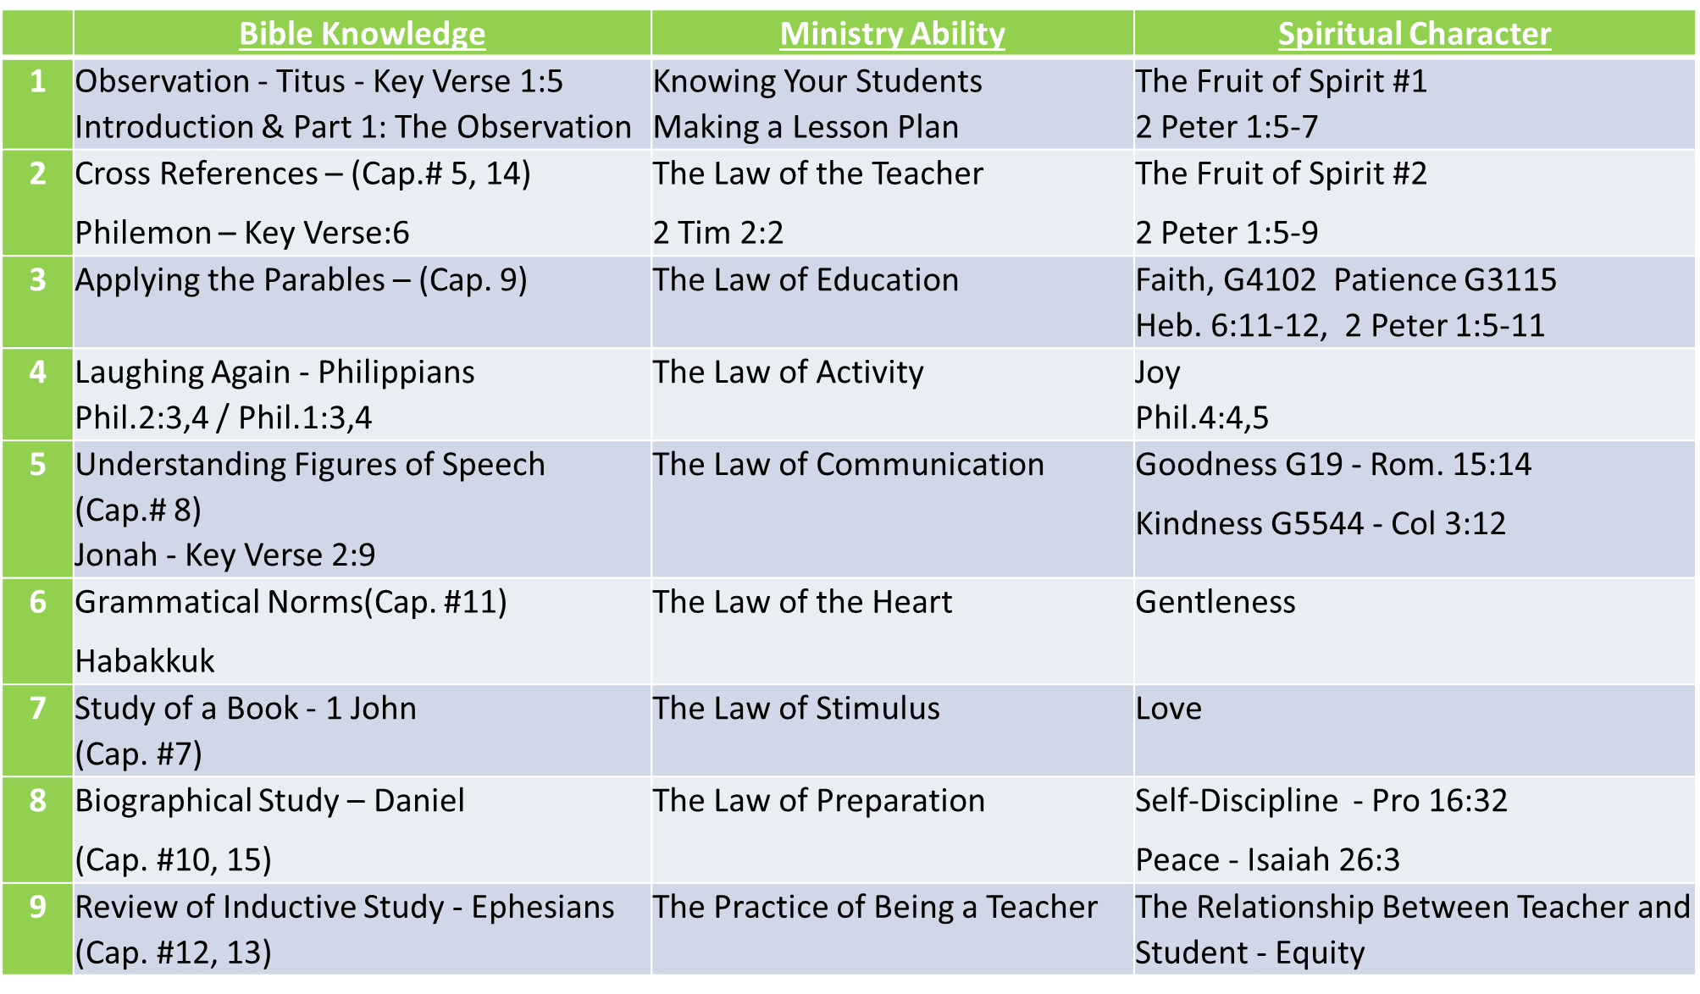

**NOTES AND OBSERVATIONS**



**Why we have exams at the end of trimesters and levels?**

* + To follow up on putting into practice what it has been learned.
  + For the student to review the main points of each subject.
  + To be able to observe the progress and God’s work in and through the disciple’s life.
  + To correct and re-enforce weak points in the disciple’s life.

# **How to use the class time. (two hours)**

* + - 1. Start **__________________**with a prayer and ask each one about the application from the previous week and/or memory verses. (10 to 20 minutes depending on the group size).
      2. Review the homework for Christian Character (25 to 35 minutes).
      3. Review the homework for Ministry Ability (25 to 35 minutes).
      4. Review the homework for Bible Knowledge (25 to 35 minutes).
      5. Finish the time stating clearly the assignments for the next week and prayer for any petitions.
  + Avoid **_________** (“chasing rabbits”) that are interesting but are not helpful or closely related to the areas being studied.
  + Be sure that each student has at least one **_________**application that the student will put into practice this week.

**Key Summary Points**

1. It is the **_________**part of the church’s ministry.
2. Christian **_________**makes ministry ability and Bible knowledge affective.
3. The **_________**is segmented and sequential.
4. There is mutual **__________________**in a covenantal relationship.
5. The emphasis is putting into practice what is learned. **Each subject has measureable or observable behavioral goals.**
6. How one is **_________**will affect discipleship.
7. **__________________**is life-long

**How to kill the discipleship group!**

1. **_____________** the information to the student.

2. Do the **_____________** during the class.

3. **_____________** much of the text in class.

4. Be **_____________** when someone gives a wrong answer.

5. Arrive **_____________** to class.

6. Do not be **_____________** for class.

7. Ask questions that do not require much **_____________**.

8. Don’t **_____________** the students to put into practice the concrete application nor ask them if they have done it the next week.

9. Don’t **_____________** for the students.

10. Don’t take time to deal with **special** **_____________** in the lives of the students.

11**.** Don’t be **_____________** to the Spirit’s leading.

**Questions from the homework.**

1. From what you have read here, what concept or idea is the most needed in your church?   
     
   Most needed in you?
2. From what you have read, what is either new to you or has been practiced little in your life?
3. What are the attitudes you would have to change to become a part of such a discipleship group?
4. What would be the changes in the use of your time that need to take place for you to faithfully participate in a discipleship group and grow as a disciple of Christ? (Be very specific about the changes)
5. What questions do you have about such a discipleship ministry described above?